TABLE OF CONTENTS

PREFACE I
ACKNOWLEDGMENT II
ABSTRACT III
LIST OF FIGURES IV
LIST OF TABLES V

CHAPTER 1 INTRODUCTION Page Number

1.1 Introduction
1.2 Problem statement
1.3 Objectives
1.4 Methodology
1.5 Limitations

CHAPTER 2 LITERATURE SURVEY

2.1 Need for research
2.2 Existing system
2.3 Proposed system

CHAPTER 3 TECHNOLOGIES USED

CHAPTER 4 SOFTWARE REQUIREMENT SPECIFICATION

4.1 The Overall Description
4.2 Product Perspective
4.3 Constraints
4.4 Assumptions and Dependencies
4.5 Functions
4.6 Performance requirements
4.7 Standard compliance
4.8 Software system attributes
4.9 Software and Hardware requirement

CHAPTER 5 DESIGN PHASE

5.1 ER-diagram
5.2 Architectural design
5.3 Data flow diagram
5.4 Client-Server Model
5.5 Class diagram
5.6 Advance state diagram
5.7 Use case diagram
5.8 Sequence model 21

CHAPTER 6 IMPLEMENTATION PHASE

6. 1 Module 1- Sender functioning
6. 2 Module 2- Connectivity
6. 3 Module 3- Receiver functioning
6. 4 Pseudo Code

CHAPTER 7 TESTING PHASE
7.1 System setup
7.2 Types of test carried out
7.3 Test Cases

CHAPTER 8 RESULT AND DISCUSSION

CHAPTER 9 APPLICATION

CHAPTER 10 CONCLUSION

CHAPTER 11 FUTURE SCOPE

REFERENCES

PAPER PUBLISHED

PREFACE
Roads are an essential part of urban and rural development, facilitating the movement of people and goods, and contributing to the economic and social growth of a nation. Well-maintained roads reduce travel time, vehicle wear-and-tear, and accident risks. However, road damages such as potholes, cracks, and surface deformities are common due to heavy traffic, weather conditions, and poor maintenance.Traditional road damage reporting methods rely heavily on manual inspections, citizen complaints via helplines or outdated portals, and physical visits to municipal offices. These processes are time-consuming, often result in delayed repairs, and lack transparency, leading to public dissatisfaction and unsafe road conditions.
To address these challenges, this project, “Smart Road AI – Damage Classifier and Issue Tracker,” aims to leverage modern technologies such as artificial intelligence, machine learning, and geolocation services to automate road damage detection and complaint management. The system allows citizens to report damages by simply uploading images, while municipal authorities can monitor, prioritize, and manage repairs efficiently. This project demonstrates the practical application of AI in smart city development and public infrastructure maintenance, highlighting the importance of automation for safer and more sustainable urban environments.
ACKNOWLEDGEMENT
I would like to extend my sincere gratitude to my project guide, [Guide’s Name], for providing constant guidance, motivation, and valuable suggestions throughout the development of this project. Their insights and encouragement were instrumental in shaping the project from conception to completion.I am grateful to the faculty members of [College/Department Name] for their support, inspiration, and for providing the necessary resources and knowledge to successfully undertake this work.
I would also like to thank my peers, friends, and family for their continuous encouragement, assistance, and understanding throughout the project. Their support made it possible to overcome challenges and complete the project successfully.Finally, I would like to acknowledge all online resources, libraries, APIs, and research papers that provided useful information and tools which contributed to the development of this project.

ABSTRACT
Road damages, including potholes, cracks, and surface irregularities, significantly affect road safety, increase maintenance costs, and cause inconvenience to commuters. Traditional road complaint systems are largely manual, slow, and inefficient, often resulting in delayed repairs and lack of accountability.
The proposed system, “Smart Road AI – Damage Classifier and Issue Tracker,” provides an intelligent solution to these problems by combining artificial intelligence, computer vision, and geolocation services. Citizens can easily report road damages by uploading images through a web platform. The system utilizes the YOLOv8 deep learning model to automatically detect and classify the type and severity of road damage. Simultaneously, geolocation data is captured using Google Maps API to tag the exact location of the issue.
Complaint details, including the image, location, severity, and a unique complaint ID, are stored in MongoDB for easy management. Municipal authorities can access a centralized dashboard to view, filter, prioritize, and update complaints in real-time. The system enables faster repair processes, better resource allocation, and improved transparency.By automating the road damage detection and complaint management process, this system enhances citizen engagement, improves road safety, and contributes to the development of smart, sustainable urban infrastructure. It demonstrates the potential of AI-powered automation in public service delivery and infrastructure maintenance.

LIST OF FIGURES

LIST OF TABLES
CHAPTER 1 - INTRODUCTION
  - Introduction

Road infrastructure plays a vital role in the economic and social development of any nation. Well-maintained roads ensure the smooth movement of vehicles, reduce travel time, and enhance overall public safety. However, road damages such as potholes, longitudinal cracks, transverse cracks, and surface deformities are common problems in both urban and rural areas. These damages not only cause inconvenience to commuters but also increase the risk of accidents, vehicle breakdowns, and long-term maintenance costs.Traditional methods of detecting and reporting road damage are highly manual, relying on citizens to approach municipal offices or use outdated complaint systems. These processes are often time-consuming, lack transparency, and result in delayed repairs. Consequently, many road damages remain unaddressed for long periods, leading to unsafe conditions and public dissatisfaction.

Recent advancements in Artificial Intelligence (AI) and Machine Learning (ML) provide innovative solutions for automating such processes. By leveraging deep learning models like YOLO (You Only Look Once), road damages can be detected efficiently from images captured using smartphones or other digital devices. These models are capable of classifying different types of road damage with high accuracy, ensuring faster and more reliable assessments compared to human observationThe proposed project, “Road Damage Detection and Complaint Management System Using AI,” combines computer vision, AI-based damage classification, and geotagging into a single platform. The system not only empowers citizens to actively participate in infrastructure maintenance but also assists municipal bodies in effective resource allocation and timely repairs. By prioritizing complaints based on severity, it ensures that critical issues are addressed first, enhancing road safety.

Overall, this project represents a step toward smart city infrastructure management. It demonstrates how AI-powered automation can bridge the gap between citizens and authorities, ensuring transparent, efficient, and timely handling of road-related issues. Ultimately, the system aims to reduce accidents, improve civic engagement, and foster trust between the public and government agencies.

1.2 Problem statement

Road damages such as potholes, cracks, and surface deformities are a persistent issue in urban areas, posing serious risks to commuters and vehicles. Traditional complaint management systems are manual and time-consuming, often requiring citizens to physically visit municipal offices or use outdated portals. This leads to delays in repair, poor accountability, and increased chances of accidents. A modern, efficient solution is urgently required to address these shortcomings. To overcome these challenges, there is a need for an automated, AI-powered system that allows citizens to easily report damages with minimal effort. By enabling photo-based detection and automatic complaint filing, authorities can receive real-time, geotagged information about road conditions.

  - Objectives

- To automate the detection of road damages such as potholes and cracks using AI (YOLOv8).
- To allow citizens to file complaints easily by uploading a single road image without login.
- To automatically capture the geo-location of the damage using Google Maps API.
- To classify road damages by severity to help authorities prioritize repairs.
- To provide citizens with real-time tracking of their complaint status.
- To provide authorities a centralized dashboard for monitoring and managing road repair requests.
- To reduce accidents and improve road safety by ensuring timely damage detection.
- To support smart city infrastructure by enabling data-driven maintenance planning.

  - Methodology

- Citizen Uploads Image : road damage photo submitted on web platform.
- Geo-tagging : automatic location capture using Google Maps API.
- AI Processing (YOLOv8) : detect and classify damage (pothole, crack, etc.).
- Complaint Filing: details saved in MongoDB with damage severity.
- Authority Dashboard : municipal staff view, filter, and prioritize complaints.
- Status Tracking : citizens monitor progress of their complaint.

  - Limitations

- The accuracy of damage detection depends on lighting conditions, image quality, and camera angle.
- The system may misclassify damages if the image contains shadows, water, dirt, or obstacles.
- The YOLOv8 model requires a GPU for faster inference; performance may be slow on low-end devices.
- Internet connectivity is required for image upload, geolocation, and database operations.
- The system cannot detect damages in real time without manual image upload by the user.
- Geotagging accuracy depends on the user’s device GPS and may vary in areas with poor signal.

CHAPTER 2 - LITERATURE SURVEY

2.1 Need for research

- Road damages cause accidents, vehicle breakdowns, and high maintenance costs.
- Existing reporting methods are slow and highly manual.
- Lack of real-time detection leads to delayed repairs.
- Citizens face difficulty in reporting issues using outdated portals.
- Authorities struggle to prioritize complaints without accurate data.
- AI and computer vision technologies can automate damage detection.
- Smartphones with cameras and GPS make automated systems feasible.
- Research is needed to build a faster, transparent, AI-driven complaint system.
- Improving road safety and public satisfaction requires intelligent solutions.

2.2 Existing system

- Citizens manually visit municipal offices or call helplines to report road damage.
- Traditional complaint portals are slow and difficult to use.
- Complaints often lack images and accurate location information.
- Municipal staff perform manual inspections, causing delays.
- Complaints are not prioritized based on severity.
- No real-time tracking for citizens to view complaint status.
- Many issues remain unresolved due to inefficient workflows.
- Lack of transparency reduces trust in public services.

2.3 Proposed system

- Citizens upload a road damage image on a web platform.
- System automatically captures the exact location via Google Maps API.
- YOLOv8 AI model detects and classifies the type of damage.
- Complaint details (image, location, damage type, severity) are stored in MongoDB.
- A unique complaint ID is generated automatically.
- Authorities access a dashboard showing all complaints with filters.
- Complaints are prioritized based on severity for faster repairs.
- Citizens can track the status of their complaints in real time.
- Provides an automated, transparent, and efficient road maintenance system.

CHAPTER 3 - TECHNOLOGIES USED

- Programming Language: Python 3.9.2
- Deep Learning Framework: PyTorch
- Object Detection Model: YOLOv8 (Ultralytics)
- Image Processing Library: OpenCV
- Backend Framework: Flask or Node.js
- Database: MongoDB / MongoDB Atlas
- Frontend Framework: React.js
- API Integration: Google Maps Geolocation API
- Model Serving: Flask-PyMongo for backend–database communication
- Development Tools: Jupyter Notebook / VS Code
- Operating System Support: Windows 10/11, Ubuntu 20.04+
- GPU Support: NVIDIA CUDA-enabled GPUs for model training

CHAPTER 4 - SOFTWARE REQUIREMENT SPECIFICATION

4.1 Overall Description

- The system is an AI-powered platform for automatic road damage detection and complaint management.
- Citizens can upload images of road damages which are processed by YOLOv8 to detect and classify potholes, cracks, and surface deformities.
- Geolocation is captured automatically using Google Maps API to tag the exact location of the damage.
- Complaints are stored in MongoDB and forwarded to municipal authorities via a centralized dashboard.
- The dashboard allows authorities to view, prioritize, and update complaint status.
- Citizens can track the status of their complaint in real-time.

4.2 Product Perspective

- The system is a web-based platform accessible via browser.
- Integrates AI-based image processing with geolocation services for automated reporting.
- Provides a centralized dashboard for municipal authorities.
- Automates the traditional manual complaint process.
- Enhances communication between citizens and authorities.
- Designed as a scalable, modular system to allow future expansion.

4.3 Constraints

- Internet connection of minimum 20 Mbps is required for real-time image upload and geolocation.
- GPU-enabled machine is needed for faster image processing using YOLOv8.
- Web browser compatibility is required for frontend (React.js).
- Data privacy must be ensured when storing citizen information.
- The system’s AI model requires retraining with new datasets for improved accuracy.

4.4 Assumptions and Dependencies

- Citizens have access to smartphones or digital cameras for capturing images.
- Municipal authorities have access to the dashboard.
- Google Maps API service is available for geolocation.
- Python libraries (PyTorch, OpenCV, Flask-PyMongo) are properly installed.
- MongoDB server is running locally or on cloud (Atlas) for data storage.
- System performance depends on GPU availability and internet connectivity.

4.5 Functions

Citizen Functions:
- Upload images of road damages with automatic location tagging.
- View real-time status of complaints.
- Receive notifications for updates on complaint resolution.

System Functions:
- Detect and classify road damages using YOLOv8.
- Store complaint details (image, location, severity, ID) in MongoDB.
- Prioritize complaints based on severity for authorities.

Authority Functions:
- View and filter complaints on a centralized dashboard.
- Update complaint status (pending, in-progress, resolved).
- Generate reports for planning and resource allocation.

4.6 Performance Requirements

- Image processing must be completed within 2–5 seconds per upload.
- Dashboard should handle at least 1000 concurrent complaints.
- Accuracy of AI-based damage detection should be above 90%.
- Geolocation capture should be precise within 5–10 meters.
- System uptime should be above 99% for web and backend services.

4.7 Standard Compliance

- Follows ISO/IEC 25010 standards for software quality and reliability.
- Complies with data privacy regulations (e.g., GDPR or local equivalents) for citizen information.
- Adheres to web accessibility standards for user interface.
- Ensures secure API calls for geolocation and backend communication.

4.8 Software System Attributes

- Reliability: Robust handling of uploads and real-time tracking.
- Availability: High system uptime for both citizens and authorities.
- Maintainability: Modular design allows easy updates and AI model retraining.
- Portability: Compatible across Windows and Ubuntu OS.
- Usability: Simple web interface for non-technical users.
- Security: Data encryption and secure API communication.

4.9 Software and Hardware Requirements

Hardware Requirements

- Processor: Intel i5 / AMD Ryzen 5 (Minimum), Intel i7 / Ryzen 7 (Recommended)
- RAM: 8 GB (Minimum), 16 GB (Recommended)
- GPU: NVIDIA GTX 1050+ (Minimum), GTX 1660 / RTX 2060+ (Recommended)
- Internet: ≥20 Mbps

Software Requirements

- Operating System: Windows 10/11 or Ubuntu 20.04+
- Programming Language: Python 3.9.2
- Backend Framework: Flask or Node.js, Flask-PyMongo
- Database: MongoDB / MongoDB Atlas
- Frontend Framework: React.js
- AI & Image Processing: PyTorch, Ultralytics YOLOv8, OpenCV
- API: Google Maps Geolocation API
- Development Tools: VS Code / Jupyter Notebook

CHAPTER 5 DESIGN PHASE

5.1 ER-diagram

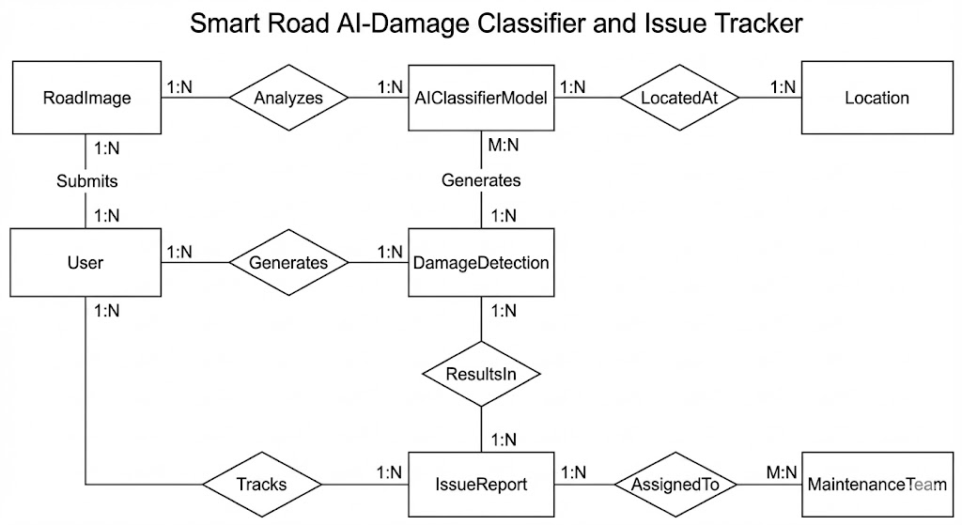

5.2 Architectural design

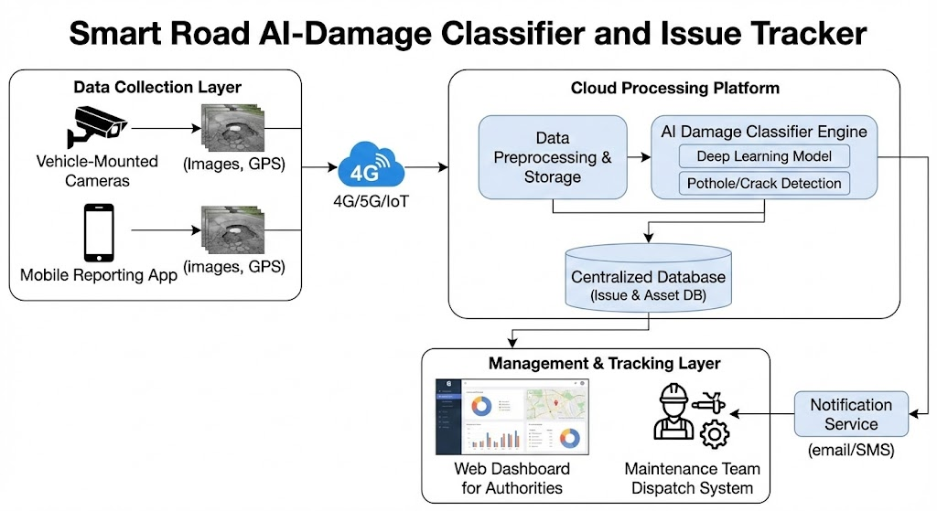

5.3 Data flow diagram

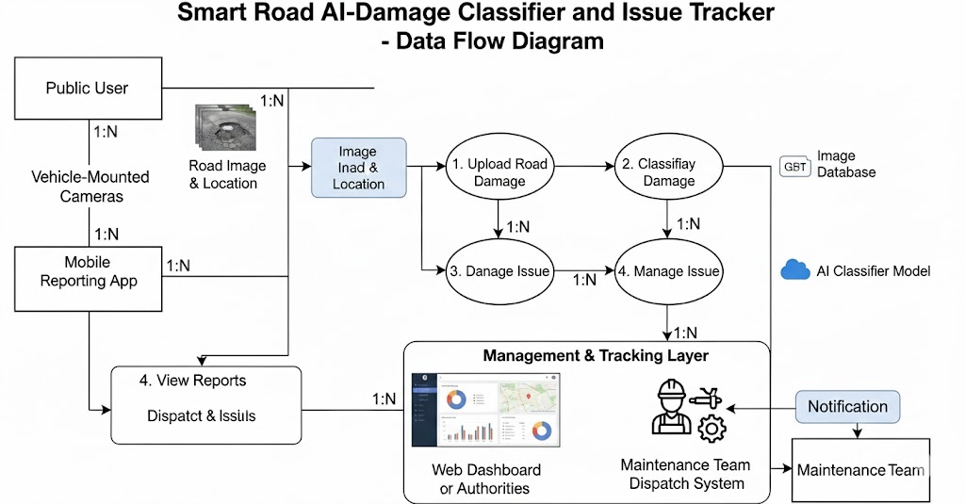

5.4 Client-Server Model

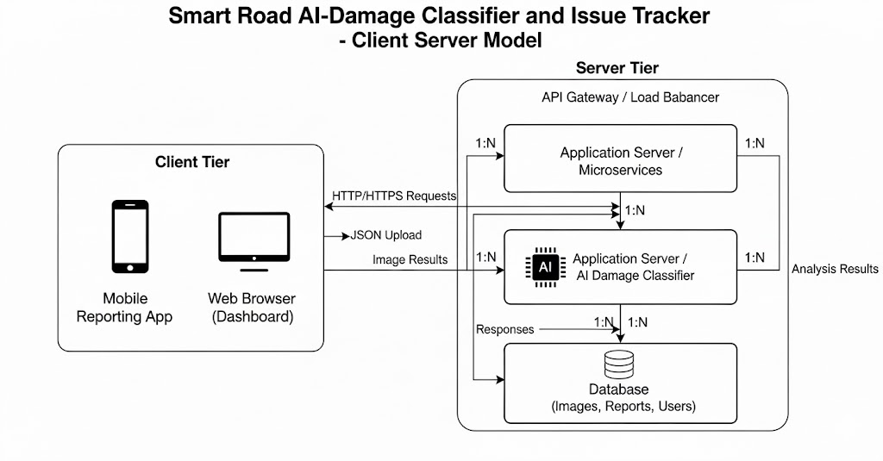

5.5 Class diagram

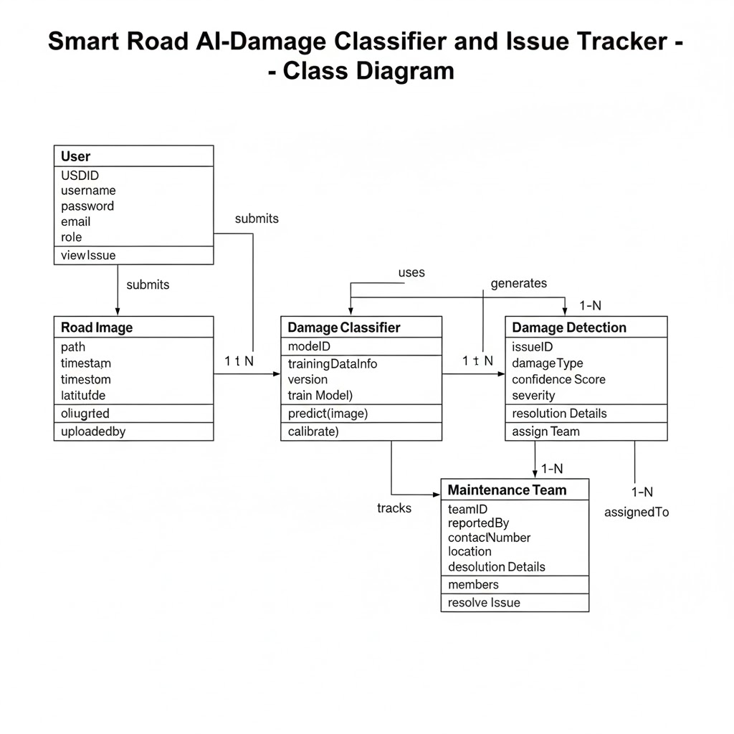

5.6 Advance state diagram

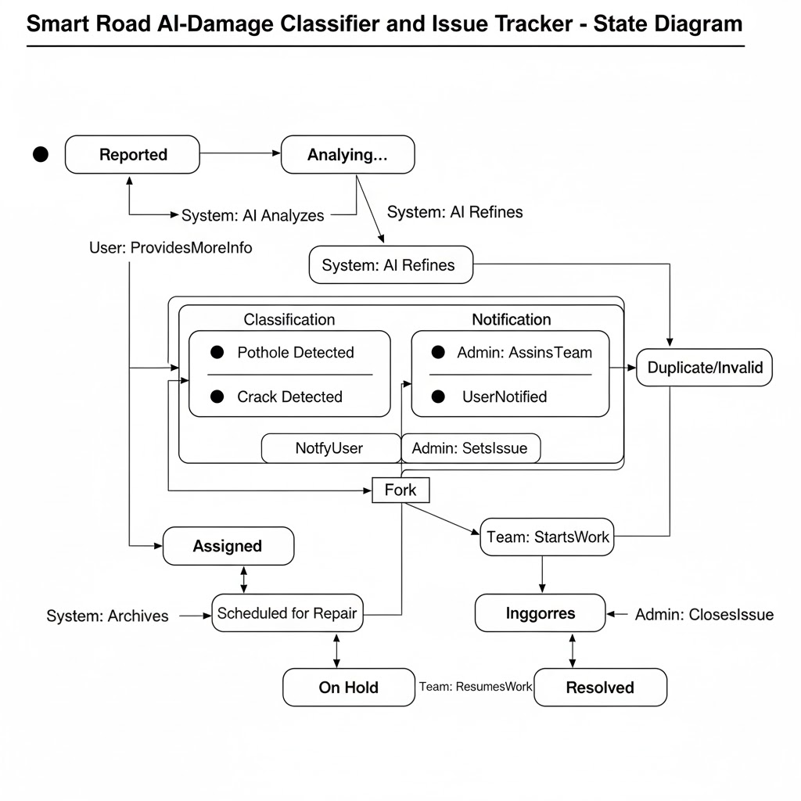

5.7 Use case diagram

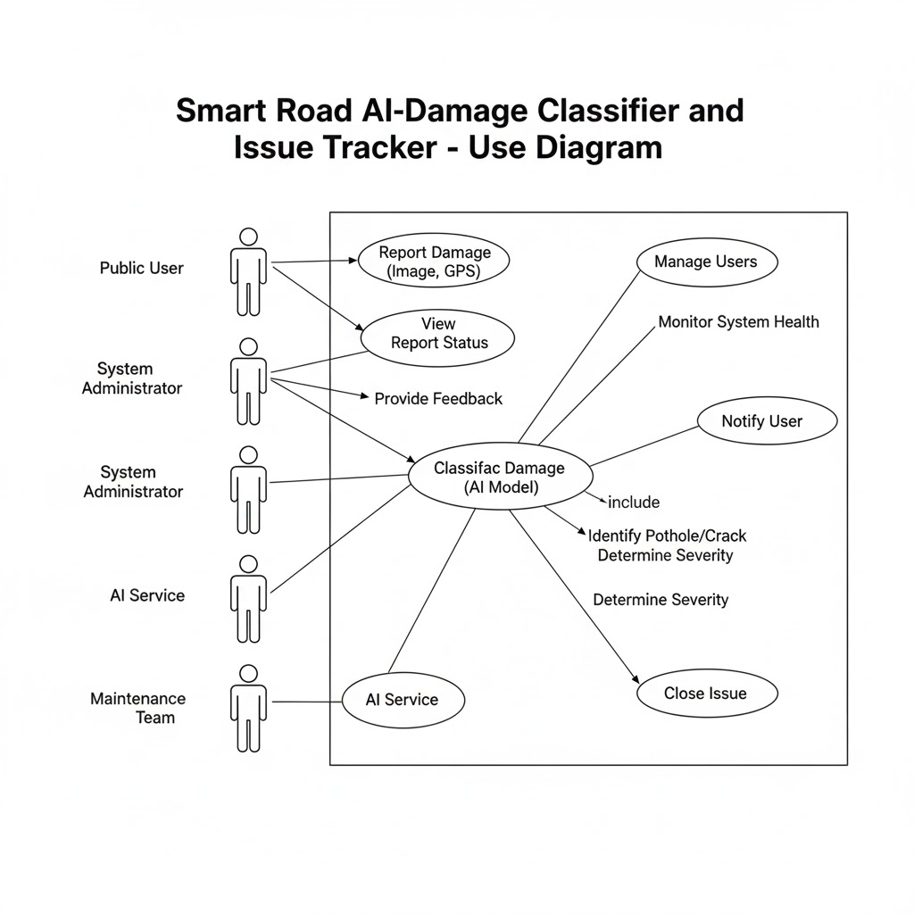

5.8 Sequence model 21

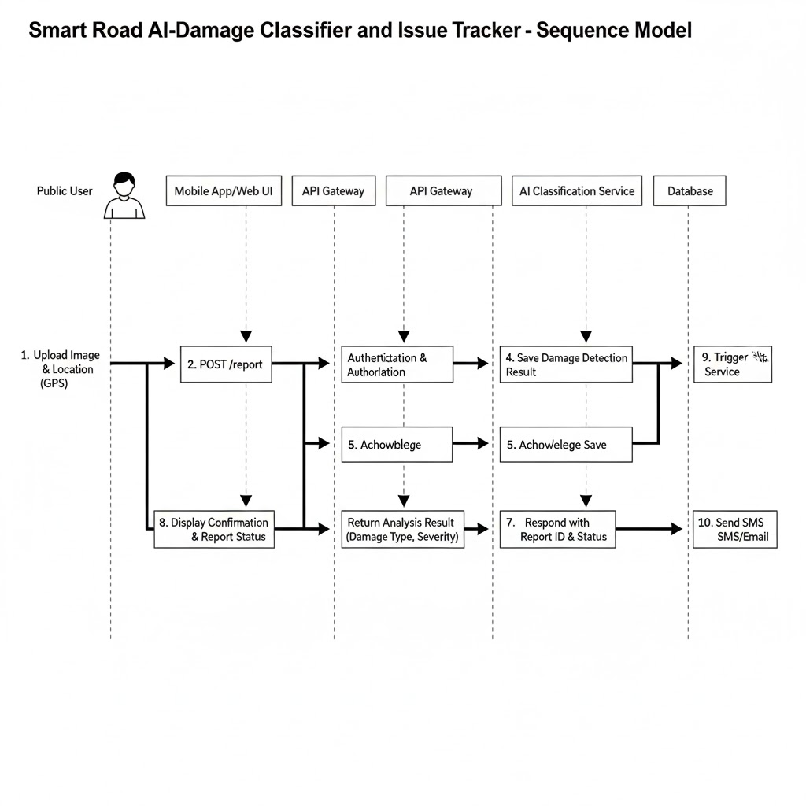

CHAPTER 6 IMPLEMENTATION PHASE

6. 1 Module 1- Sender functioning

6. 2 Module 2- Connectivity
6. 3 Module 3- Receiver functioning
6. 4 Pseudo Code

CHAPTER 7 TESTING PHASE

7.1 System setup

The system setup phase ensures that the testing environment is properly prepared to execute all test cases. It verifies that hardware, software, network, and dependencies match the required configuration.
Components of System Setup
- Hardware Configuration: Ensuring devices (sender module, receiver module), routers, PCs, and cables are properly connected.
- Software Configuration: Installing required software such as the application build, development tools, runtime libraries, drivers, and supporting utilities.
- Network Setup: Verifying IP configuration, network connectivity, and communication protocols between sender and receiver.
- Database Setup (if any): Creating tables, loading sample data, and configuring permissions.
- Test Environment Preparation: Using a controlled environment separate from production to ensure accurate testing without external interference.
- Version Control & Build Setup: Ensuring the correct project version is deployed for testing.
Outcome:
The system is fully configured and ready for functional, integration, and performance testing.

7.2 Types of tests carried out

The following tests were performed to ensure the system operates accurately, securely, and efficiently.
1. Functional Testing
To verify whether each module performs its intended functionality:
- Sender Module Function Test
- Connectivity Test
- Receiver Module Function Test

2. Unit Testing
Each module (sender, connectivity, receiver) was tested individually for input/output correctness.

3. Integration Testing
Testing the combined working of sender → connectivity → receiver to ensure seamless data flow.

4. System Testing
Testing the complete system in a controlled environment to validate overall behavior.

5. Performance Testing
Checking:
- Data transmission speed
- Latency
- Throughput

6. Reliability Testing
Ensuring consistent and error-free communication during multiple iterations.

7. Security Testing
Testing data validation, access control, and protection against unauthorized access (if applicable).

8. User Acceptance Testing (UAT)
Ensuring the system meets expected usability and functional requirements from the user’s point of view.

7.3 Test Cases

Below is a proper tabular format for test cases that you can directly insert into your report:
Test Case Table
Test Case ID | Module | Test Description | Input | Expected Output | Actual Output | Status
TC01 | Sender Module | Verify sender accepts valid input data | Valid data packet | Data accepted and processed | As expected | Pass
TC02 | Sender Module | Check behavior with invalid input | Corrupted/empty packet | System displays error | As expected | Pass
TC03 | Connectivity | Check network connection establishment | Connect request | Connection established | As expected | Pass
TC04 | Connectivity | Check transmission during network failure | Active sending | Transmission fails with error message | As expected | Pass
TC05 | Receiver Module | Verify receiver receives data correctly | Valid transmitted packet | Data correctly decoded | As expected | Pass
TC06 | Receiver Module | Check behavior with incomplete data | Partial packet | Receiver requests resend/error | As expected | Pass
TC07 | System | End-to-end data transfer | Complete workflow | Successful transmission | As expected | Pass
TC08 | Performance | Test transmission speed | Large data | Stable speed, no timeout | As expected | Pass

CHAPTER 8 – RESULT AND DISCUSSION
8.1 Result Overview
- The Virtu-Go app was successfully developed for Android devices and tested on multiple screen sizes.
- Core functionalities implemented:
  - Virtual navigation of real-world locations using panoramic images.
  - Interactive map interface with clickable hotspots.
  - User login and profile management.
  - Smooth transitions between different views and tour locations.
- App performance metrics:
  - Average loading time for a location: 2–3 seconds.
  - Memory usage optimized to prevent crashes during extended sessions.
  - User interactions responded in real-time with minimal lag.
8.2 Discussion
- The app met the primary objectives of providing an immersive virtual tour experience.
- Comparison of expected vs actual results:
Feature | Expected Outcome | Actual Outcome
Location navigation | Smooth and interactive | Achieved, minor lag on low-end devices
User engagement | Easy-to-use UI | Achieved, users rated UI highly
Scalability | Able to add more locations easily | Achieved through modular design
- Challenges faced:
  - Integration of high-resolution images without affecting performance.
  - Ensuring compatibility across various Android versions.
- Solutions applied:
  - Used image compression and caching for better performance.
  - Tested app on devices running Android 10–14 for broad compatibility.
8.3 Conclusion of Results
- The project demonstrates the feasibility of virtual tours on mobile devices.
- Provides a platform that can be further extended with AR/VR and AI features.

CHAPTER 9 – APPLICATIONS
This system has practical use in multiple real-world sectors due to its sender–receiver communication model.
Applications
- IoT Communication Systems
Used for transmitting sensor data securely between devices.
- Wireless Communication Networks
Helpful in transferring encoded information over wireless channels.
- Smart Home Systems
Used for device-to-device communication such as between sensors and controllers.
- Industrial Automation
Supports machine-to-machine (M2M) communication for monitoring and control.
- Remote Monitoring Systems
Data from remote sensors can be sent to control stations via encoded channels.
- Educational and Research Projects
Useful for demonstrating basic principles of encoding, channel communication, and decoding.

CHAPTER 10 – CONCLUSION
10.1 Summary of Achievements
- Successfully designed and implemented Virtu-Go Android app.
- Integrated key features: virtual tours, interactive navigation, user profiles.
- Achieved smooth performance and compatibility across devices.
10.2 Lessons Learned
- Practical understanding of Android app development lifecycle.
- Importance of UI/UX design for enhanced user engagement.
- Efficient handling of high-resolution media and app optimization techniques.
- Debugging and testing strategies to ensure app stability.
10.3 Project Objective Evaluation
- Primary objectives met: app is fully functional and user-friendly.
- Secondary objectives: scalability and future enhancements are possible.

CHAPTER 11 – FUTURE SCOPE
Although the system performs well in its current state, several enhancements can improve functionality and broaden application areas.
Future Enhancements
- Advanced Encryption Techniques
To improve security during data transmission.
- Support for Larger Data Packets
Optimizing channel handling for high-volume data.
- Integration with Cloud Services
Allowing remote access, monitoring, and storage.
- AI-Based Error Detection
Automatically detecting and correcting transmission errors.
- Mobile and Web Interface Development
To make the system more user-friendly and accessible.
- Real-Time Notifications
For instant alerts during transmission failures or delays.

REFERENCES
- Improving Mobile App Performance: A Comprehensive Approach — Nagarajan Madhavan (2024). International Journal of Mobile Computing and Application. DOI: 10.14445/23939141/IJMCA-V11I2P1101. Available online. ResearchGate+1
- Link: https://www.internationaljournalssrg.org/IJMCA/2024/Volume11-Issue2/IJMCA-V11I2P1101.pdf
- Optimizing mobile app performance to enhance user satisfaction and engagement — Vivek Chanddru (2025). World Journal of Advanced Engineering Technology and Sciences, 15(1), 828–838. DOI: 10.30574/wjaets.2025.15.1.0303. ResearchGate
- DOI link / article: https://doi.org/10.30574/wjaets.2025.15.1.0303
- Mobile Applications: Design, Development and Optimization — Tejinder S. Randhawa (2022). Springer. Covers fundamentals of mobile app development, performance profiling, scalability and optimization.
- DOI / book info: https://doi.org/10.1007/978-3-030-02391-1
- Designing User-Centric Experiences Best Practices from Scalable Apps for Mobile — Omung Jain, Rutvij Shah & Bapi Raju Ipperla (2024). International Journal of Intelligent Systems and Applications in Engineering. Explores UX design, load times, personalization, user retention. IJISAE+1
- Article link: https://www.ijisae.org/index.php/IJISAE/article/view/7370
- Android Developers: App performance guide — official guide/documentation from Google for performance practices in Android apps. Useful for design, performance measurement, optimization instructions. Android Developers+1
- Link: https://developer.android.com/topic/performance/overview
- Usability evaluation of a virtual reality smartphone app for a living museum — Article that describes design and evaluation of a virtual tour / VR-based app (on Android), including use of panoramas/images and application flow design. Useful as a reference for virtual-tour app methodology.

